**Lab2. 2’s complement and Binary code**

1. MATLAB

The way to compute 2’s complement of a negative number

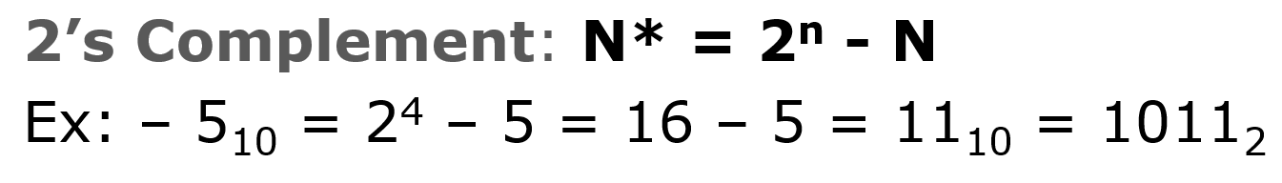

Express -12 using 6 bits in 2’s complement by hand. Write MATLAB code and do the expression, verify your result and demonstrate to me.

1. MATLAB Simulink
   1. Use one Pulse Generator and one scope. Show the clock signal in the scope. (Sample based, Amplitude=1, Period=2, Pulse width=1, Phase delay=1, Sample time=1).
   2. Design the binary code for 16 decimal number (0-15)

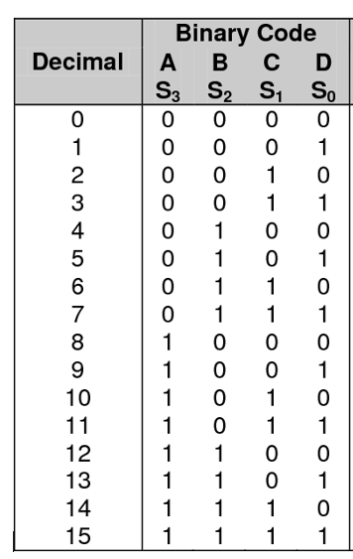

Use four pulse generators and one scope to simulate the BCD codes. Set the simulation time as 16. The waveform should show each of the binary code in the correct order.

**Demonstrate your work to me, otherwise submit all the work in canvas.**